eCMS MANUAL

OPERATIONAL REPORT

Department of Revenue and Customs
Ministry of Finance

Table of Contents
1. Introduction 1
2. Logging in as Officer 1
3. Operational Report 1
3.1. List of reports that can be generated: 2

Introduction
Operational reporting is the process of regularly providing the complete report of an organization’s day to day activities and operations. These reports provide operational insights for time intervals like hourly, daily, weekly, and monthly. Serving various functions, these reports at times need to be customized for specific insights.
The operational reports will help the manger in identifying the areas that need attention and the ones that need to be tracked regularly.

Logging in as Officer

- The user needs to log into eCMS using the url: www.ecms.gov.bt
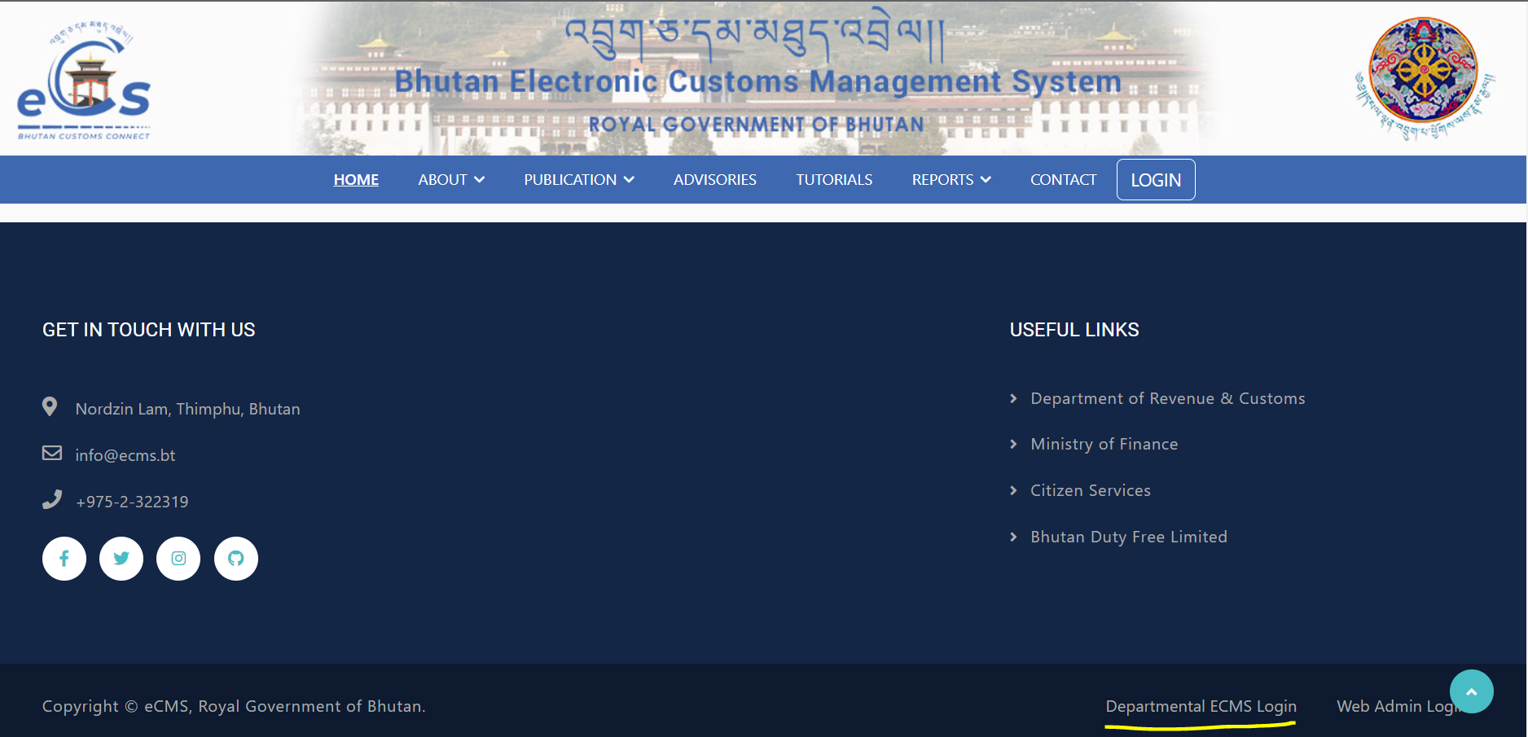
- Click on login menu and provide the required credentials to log in to the system:

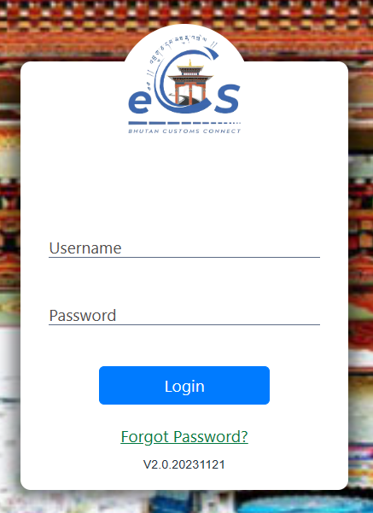

Operational Report
- In eCMS we can generate different reports based on the parameter defined.
- Click on the menu Report to check on the list if reports that can be generated.
- Select the report that you wish to generate and provide the parameter.
- Report can be generated in excel or pdf format.

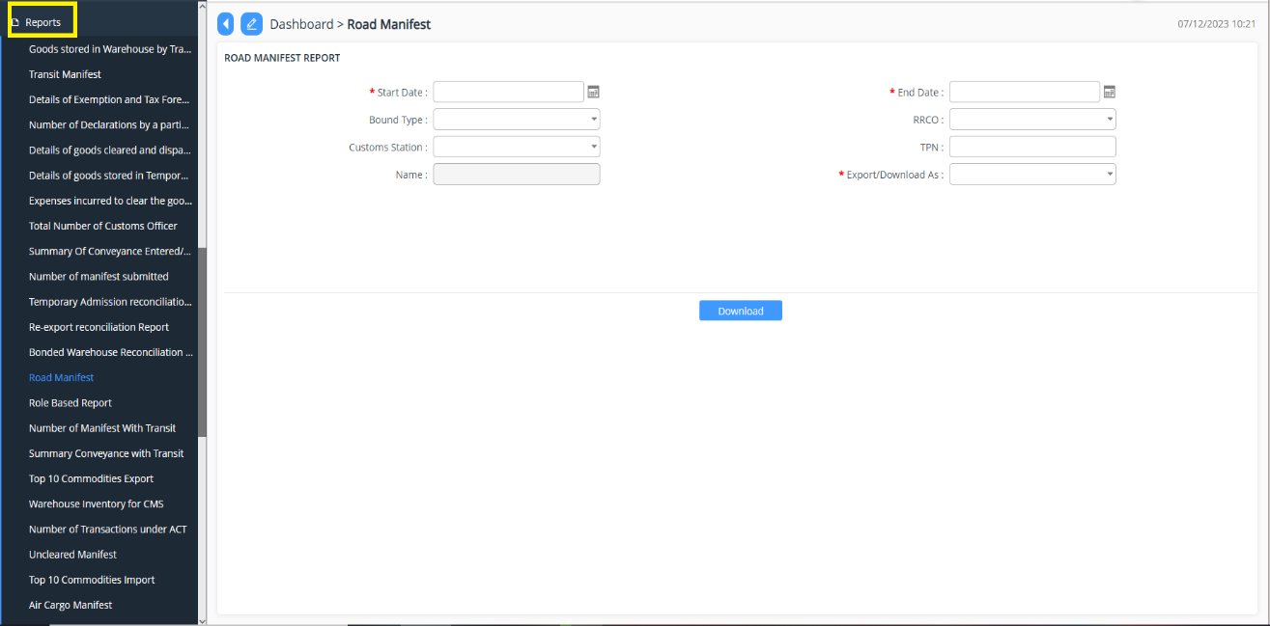

List of reports that can be generated:
- Goods Stored in warehouse by trader.

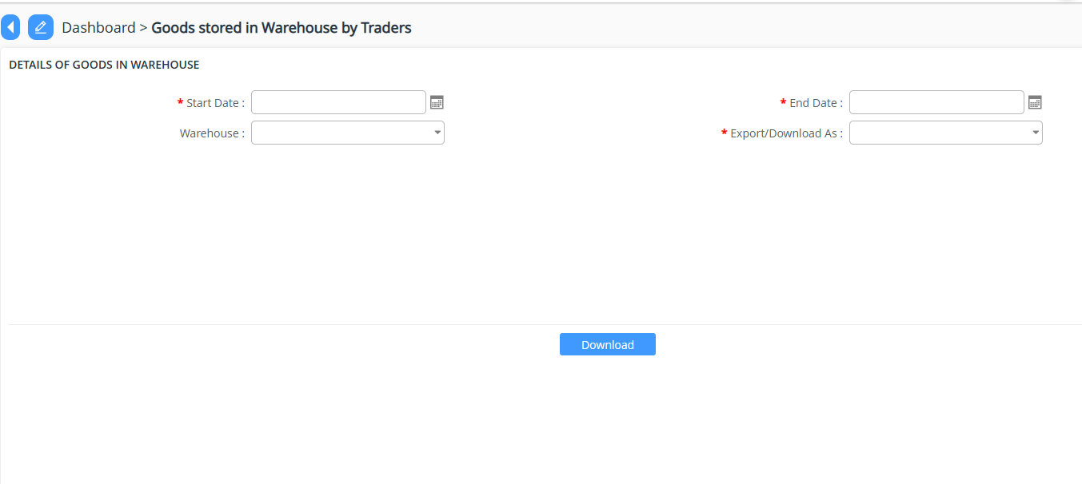
- Transit Manifest

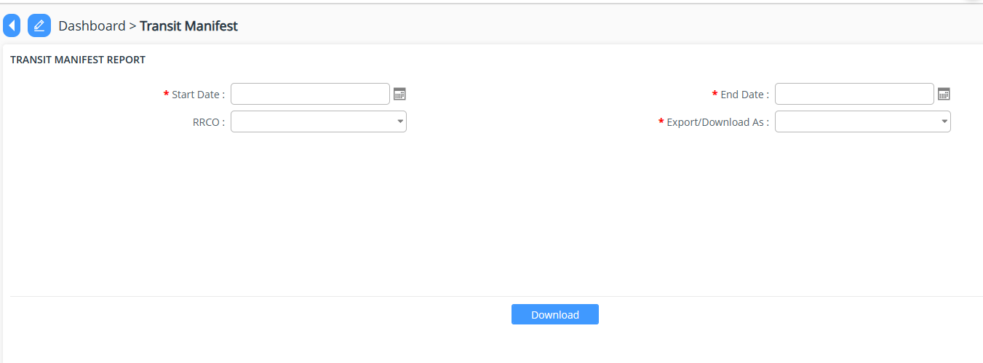

- Details of Exemption and Tax Foregone

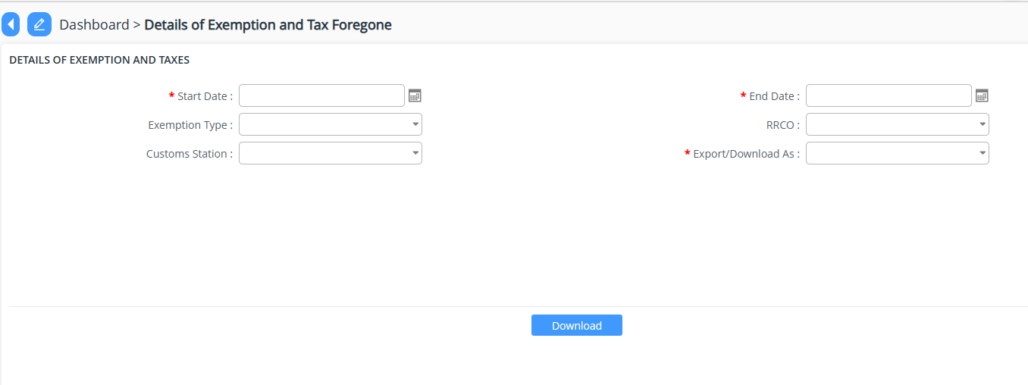
- Number of Declaration by particular CFA /Importer

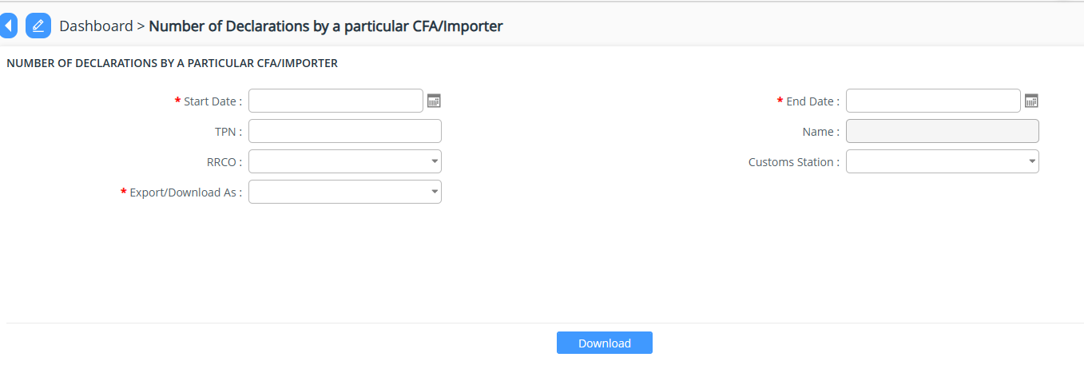
- Details of goods cleared and dispatched from LTD
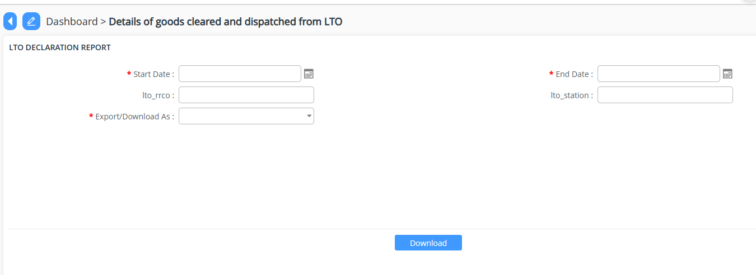
- Details of goods store in Temporary storage
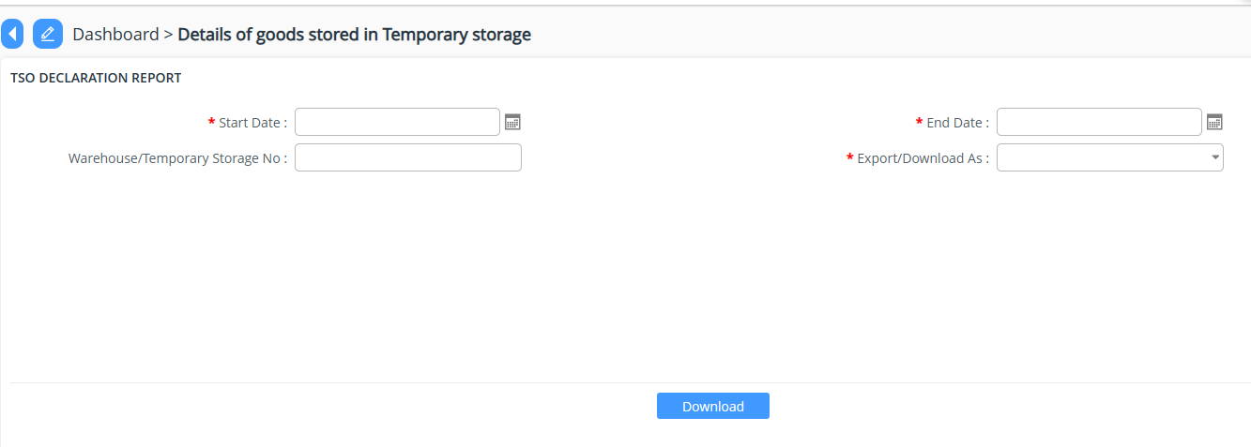
- Expense incurred to clear the goods from Kolkata
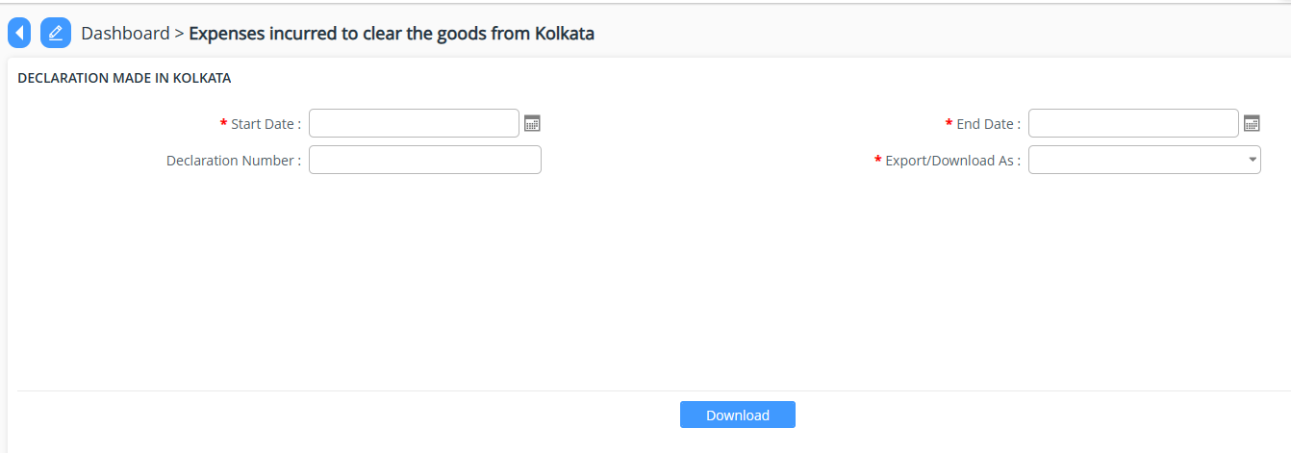
- Total number of custom officer
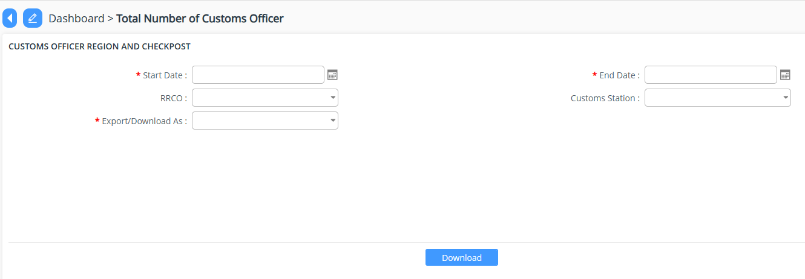
- Summary of conveyance entered/exited
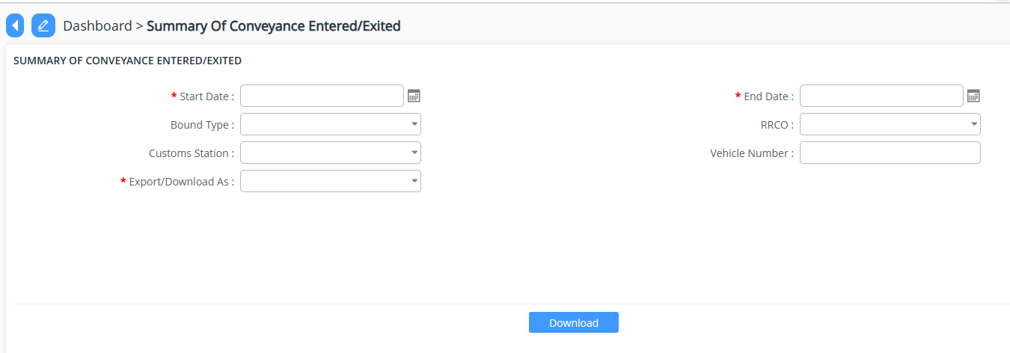
- Number of Manifest Submitted
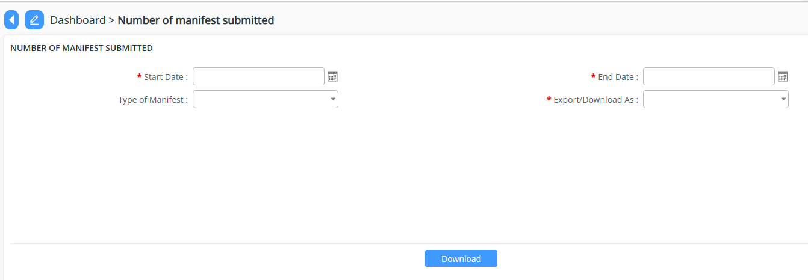
- Temporary Admission reconciliation report\
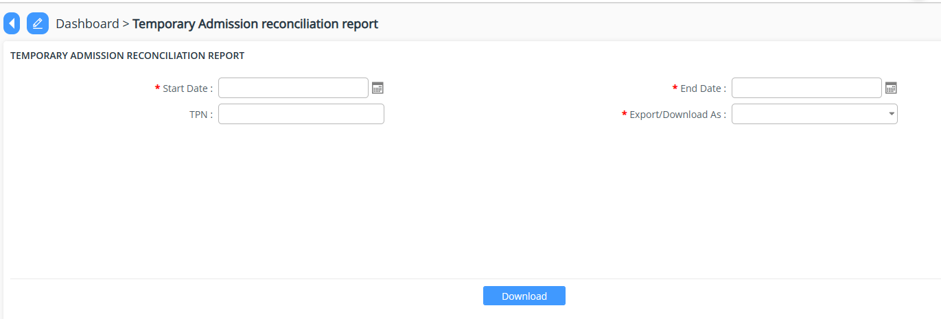
- Re-export reconciliation report
- Bonded warehouse reconciliation report
- Road Manifest
- Role Based Report
- Number of Manifest with Transit
- Summary conveyance with Transit
- Top 10 commodities Exported.
- Warehouse inventory for CMS
- Number of Transaction under ACT
- Uncleared Manifest
- Top 10 commodities import.
- Air Cargo Manifest
- Number of employee (User) Registered
- Air Passenger Manifest
- Details of goods stored in each warehouse.
- Refund exemption reconciliation report
- Total amount paid by Tax Types
- Number of Air house manifest
- Authorized Compliance trader Approved /validity.
- Number of goods in TSO
- Passenger baggage Declaration
- Passenger details
- Number of Application submitted.
- Number of Registration submitted.
- Summary of Declaration type submitted.
- Top 10 Exporter
- Top 10 Importer
- Passenger Profile

